In this lesson we are going to importing svg files or vector graphics into natron and be controlling different objects or paths within that SVG file so its gonna be really good of you have installed on your computer it’s a free alternative to Adobe Illustrator and its an awesome powerful program probably Teacher favourite open source ever so we are gonna download an SVG file so if we go to pixabay.com

Now this time instead of images and videos we choose Vector as marked below

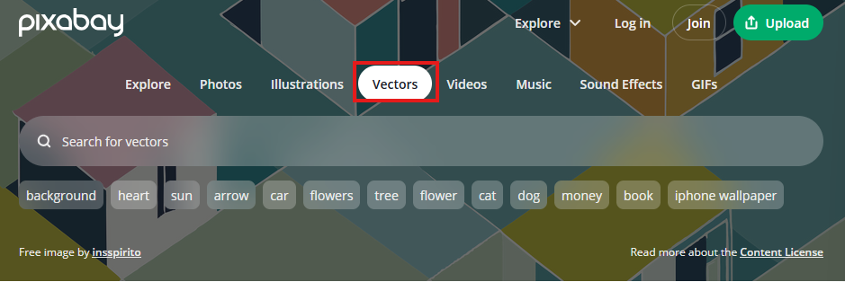

We type grass but we did not find svg image that Teacher is using so I search accordingly and I find the svg images that Teacher is using by searching “black grass sunset orange bg” and we find it as marked below

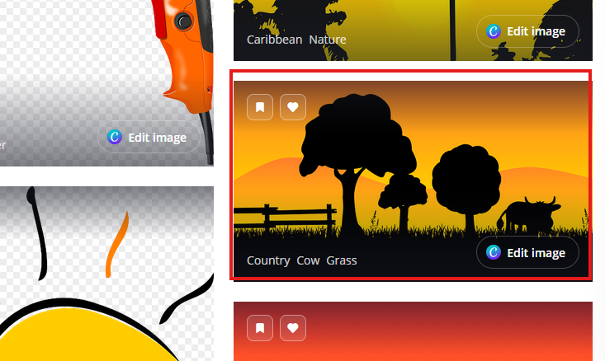

We click on it and then and in new window it look like below

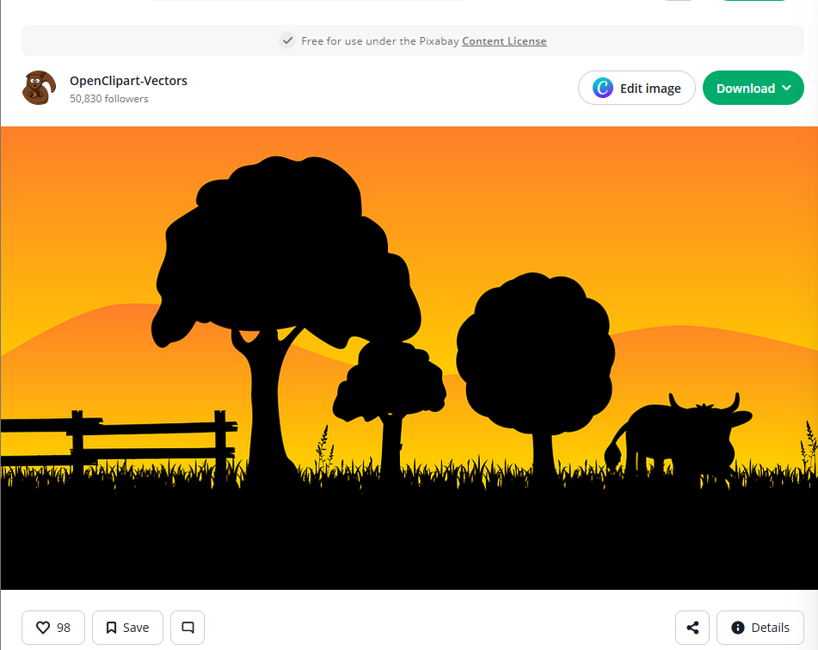

Now we download it Teacher really like this country scape with just a shadow so its kind of simple only a few colors going on so we download this and apply some animation to it

So we click on the download to open the download drop down list and then choose the video graphics (SVG)option as marked below

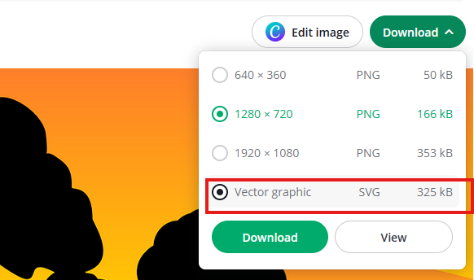

And then click on Download button and if we click on svg that is vector graphics at least that’s an option if we download the png then It’ll just be a one solid picture and we can’t control individual objects but by downloading the vector graphics we can control individual element of this and Teacher will show you how to do that in Natron Keep in mind that not all the images you download from pixabay or from anywhere are gonna have an option for SVG file It’s different if you are not familiar with it maybe just do it you know look at Wikipedia so some searching on SVG and How it works

This SVG image the teacher is taking is actually from openClipart vectors. We can use this image for free as it has free cto use licence (who knows)

Now after downloading it we open it up in browser and Inkspace. We open it in Inkspace

You can also view it by dragging and dropping it on the browser and then the tab on which it is dopped will display the svg image

As shown below

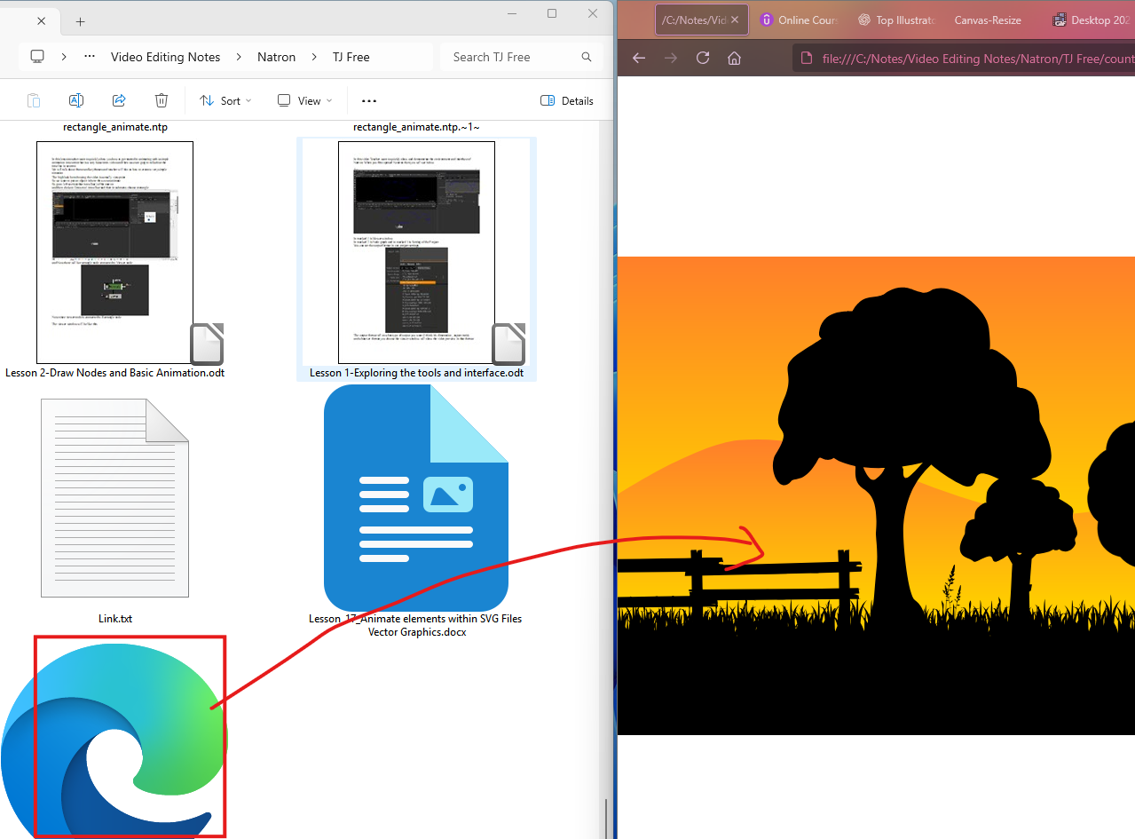

Web browsers have native support for SVG files a lot of them do we open it in Inkspace

Now it will look like below in Inkspace

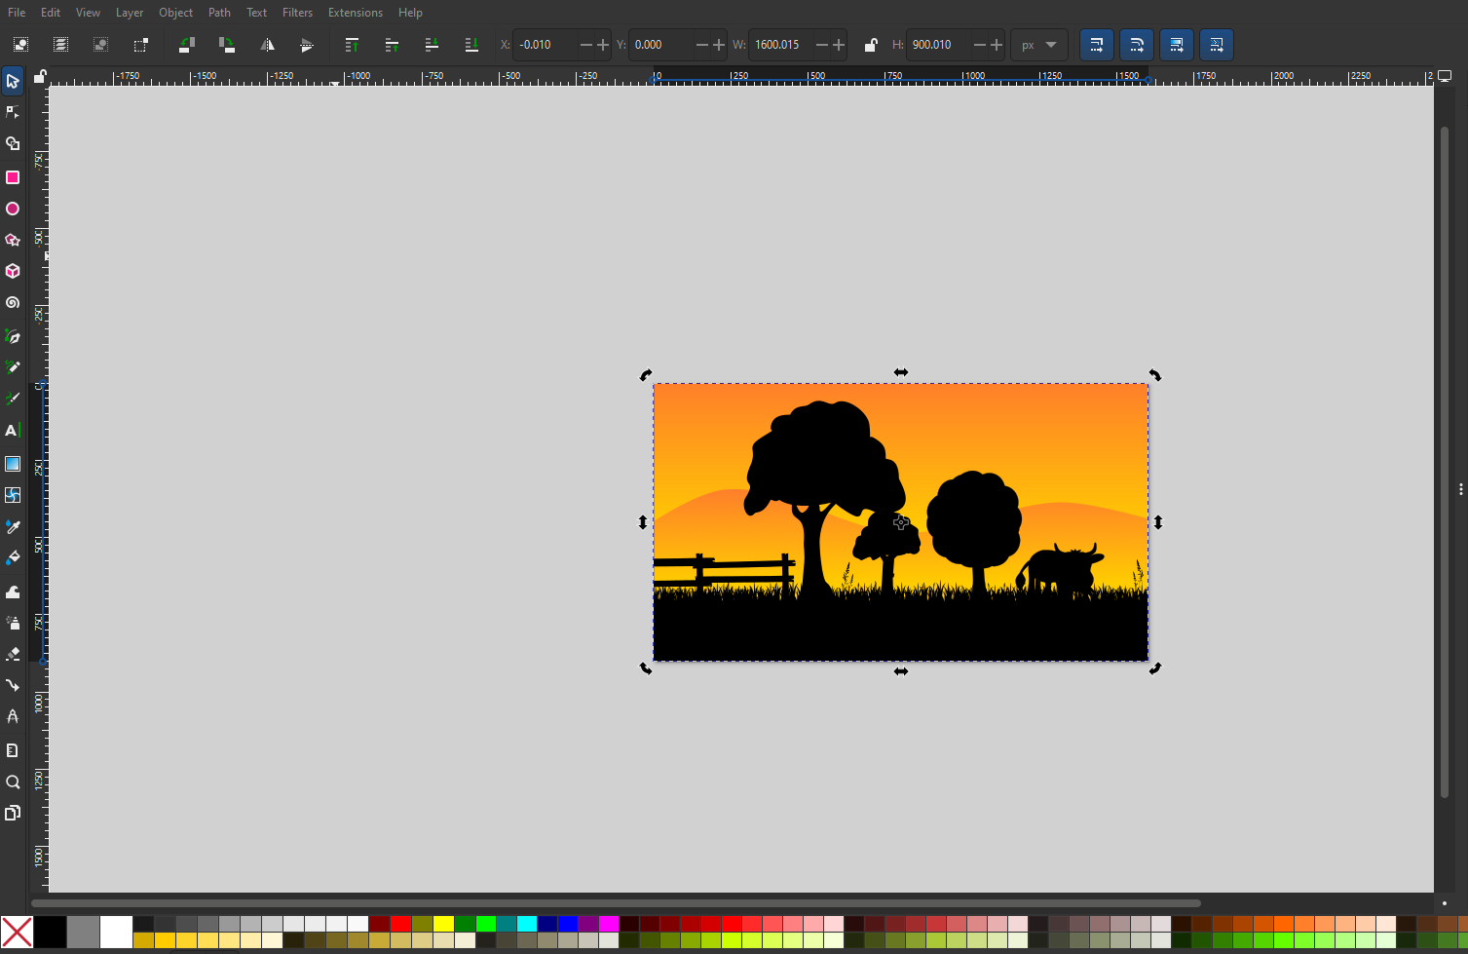

You can open it in Adobe illustrator or Inkspace or any other vector image editor so it just look like one giant picture Teacher is showing us how it will look like in Natron so we will read

2:30

it in just like we would any image or video file So we just drag and drop and now connect it to the viewer node as shown beow in node graph

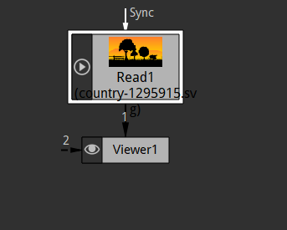

And now in viewer you can see it isi visible it look same as in Inkspace

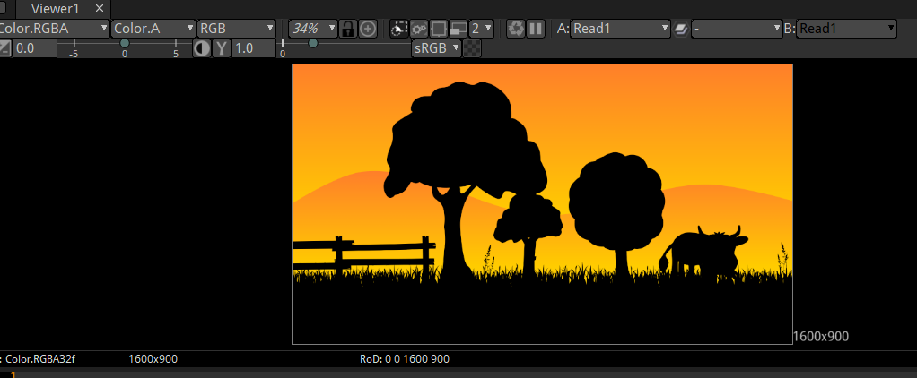

We add a transform node to the read node of the svg file by pressing T and Now in node graph will be like like below

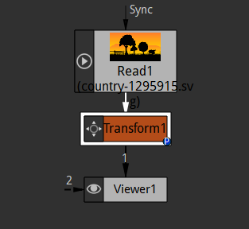

Now we can move this around you can even rotate and scale it but still at the end of the day it is just a file we don’t have any options no additional option for this

we add a merge node to the read node of our svg by pressing **M** Key after selecting the Read node

Now our node graph look like below

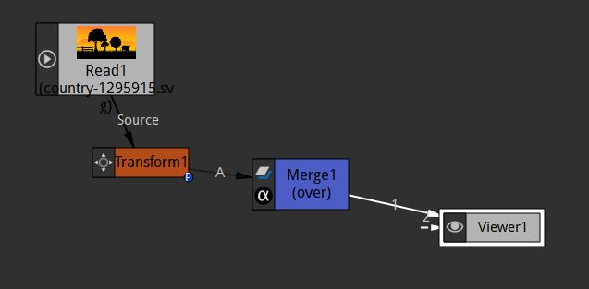

Now in merge node we have properties like A and Output layer as marked below

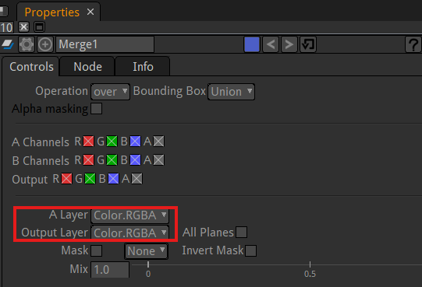

It is shown because we don’t have a B (that is read node for bg ) In out

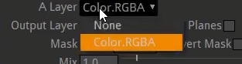

In A we have some none and Color.RGBA but that’s only option we have right now Teacher will show us How to get more options so that we can control and each individual element of this image. To do that we need to open it up in Inkspace here. Now in Inkspace it looks like below

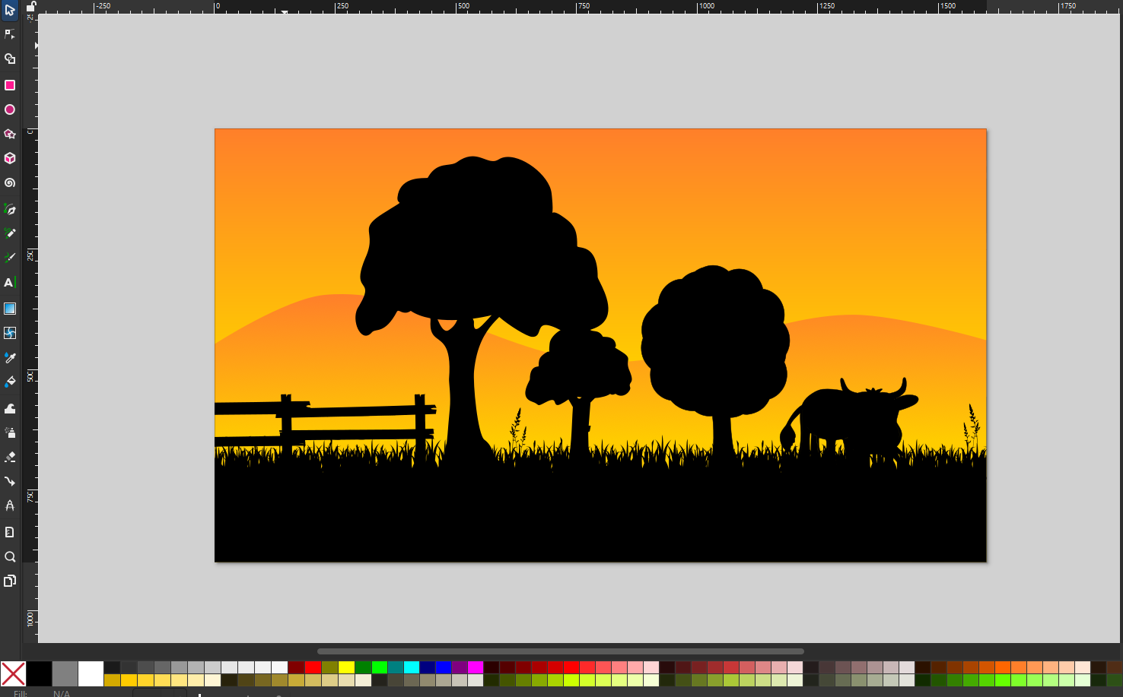

So it is our 1920 X 1080 vector graphic image which means we can scale it super large and we can scale it super small it will stay the exact same clarity and if we select it in Inkspace and press **ctrl + shift + g** on our keyboard that gonna ungroup and now it will look like below

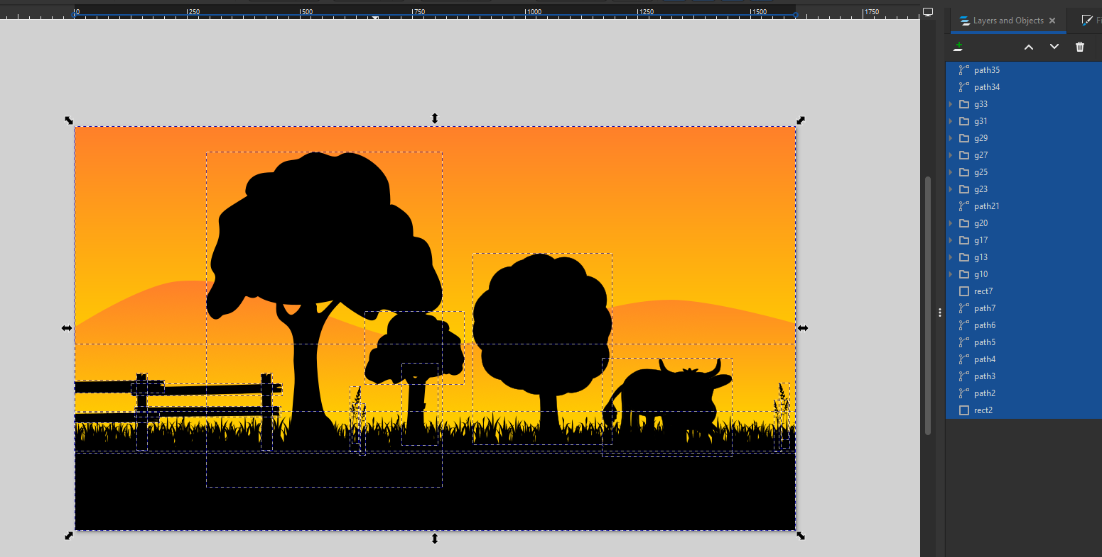

Now a lot of people will group together their entire image and within that group there probably another group SO by this ungroup we have separate different objects now we can see these trees separately if we try to ungroup our tree then it will not do anything as it is made of path (who knows)

You can see in fence there are made of separate things as shown below

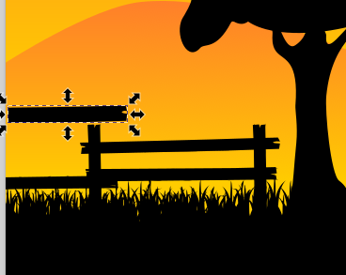

SO this is just the way the artist created the image and hten we have a cow a shown below

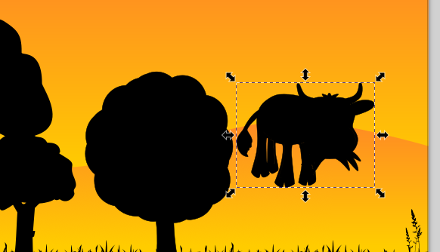

We will just leave like that ( as it was after ungroup ) and now we ungroup it

We go to file and then to save as we name it “country-ungrouped” and I save it In my natron notes

So now in natron replace the previous read node with the read node of ungrouped-country svg image.

The ungrouped svg we save as Inkspace svg there’s different types of SVG We saved it as an inkspace svg which is fine so we will open this and we will bind that to our merge node now it will look like below

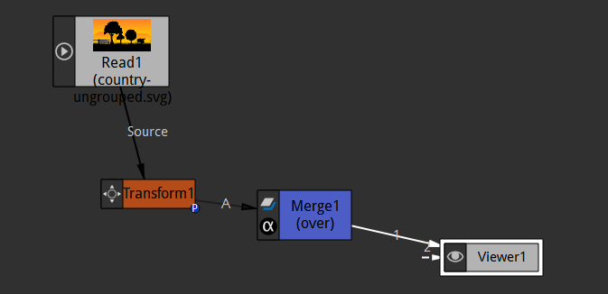

It still look the same we can’t select anything everything still there if we transform it. It will transform the whole thing but if we go to merge node properties we see A Layer then it will have a longer list as shoen below

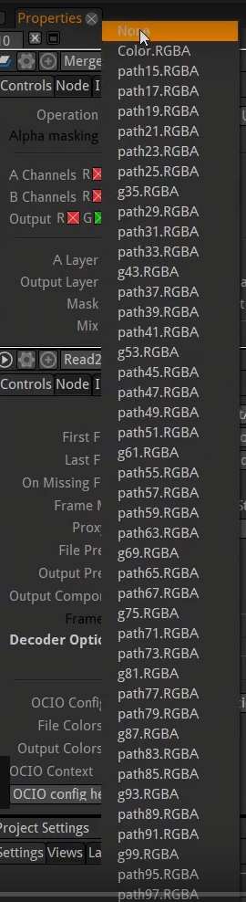

Before we only had color rgba and none now we have all these different options

5:55

if we select the path 15 but teacher is doing old images so that path name is changed

and the paths are a part of all the elements that start with g<number>.RGBA

and some elements re so small that they are not visible on the viewport and they may not be visible due to there black color as viewport also has default black color so on the background mode to see it

Now we select the path2 then viewport will look like below

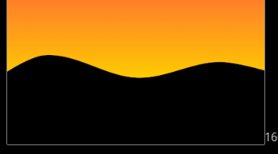

At first glance you might assume that you are seeing the mountains or hills or the sky Now we chose path 19 is not visible as shown below as the shape is in black color and the viewport is also in black color.

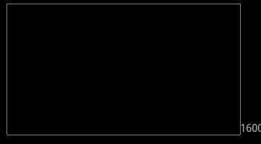

So we on the background mode then you can see the show below

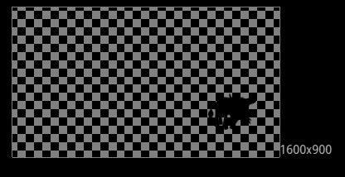

We choose the path3

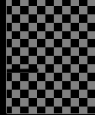

And it will show the fence So what we are seeing that every path has a different number. Some path are just like tiny like blade of grass So that’s how everything can be displayed separately. So what we can do is in merge node we choose Color.RGBA to show the full svg image as shown below

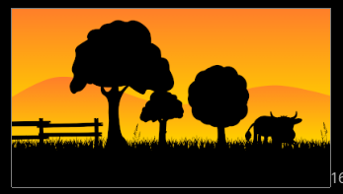

We will copy the read node of the svg image by ctrl + C and CTRL + V as shown in the node graph below

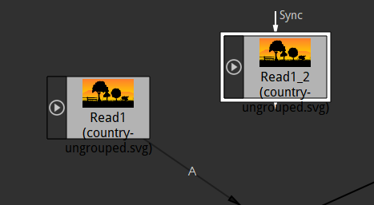

Now we will keep this read copy as a background so we disable the read node going to A part of the merge node and let the copied read node of svg go to Background part of the marge node So now this time we go to the B layer of the merge node and choose path 2 so that it shows the orange sky as shown below in the viewer panel

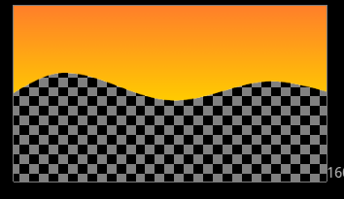

Now we disable B read node and enable A read node which is full image as shown in viewer panel as shown below

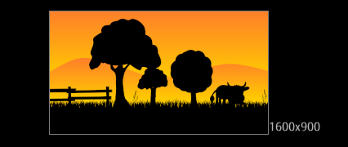

Now the project resolution was not matching to the image resolution so we changed in project setting to match to the image

Because in A layer (that is Color.RGBA) we are saying read in everything that RGBA channel red, blue , green and alpha all of it just read. So in layer A we choose the element representing cow that is path4 now make the B layer choose path2 that represents sky and enable it. Now the viewer panel will look like below

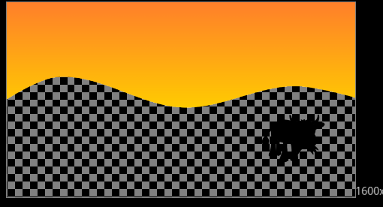

It is a very tedious work of adding multiple parts of SVG through multiple read nodes

The more complex your vector images is the more tedious it is if you just read like Teacher did you have to go thorough layer and choose what layer you want (who knows)

Now moving forward add transform node to the A read node.

Now our node graph will look like below

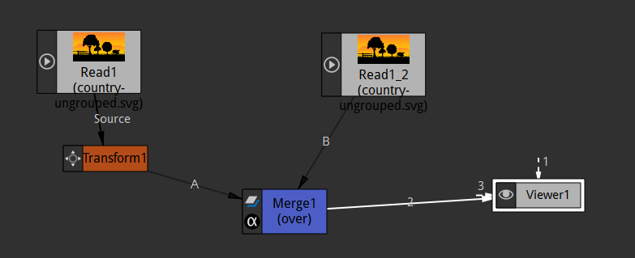

And now we can move our cow around

Now we can add animation to the cow as we add animation to any other read node in natron that we have learnt till now. So we added an animation as shown below



So we added an animation of this cow against the sky which is cool since we are reading from one file and we are just animation some part of it (who knows)

One option to speed things up is if we were to group everything together so lets say we choose the object in InkSpace that we want to animate and separate them from object that we don’t want to animate

As shown below

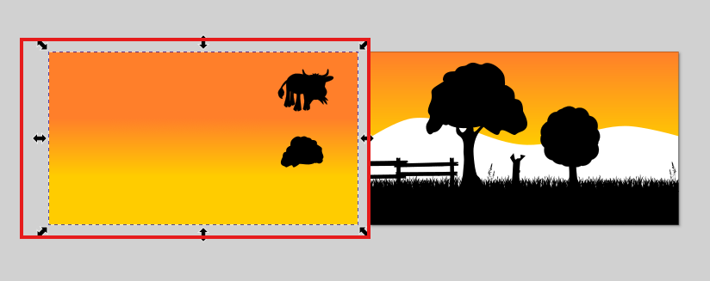

The marked one is are the things that we want to animate so we select all the unmarked one and group them and press ctrl + g. so now we have grouped it

10:14

So ow the unmarked one all moves together and it comes under one single path now or one single group in natron

Now we will bring cow and tree Now we will see them as shown below

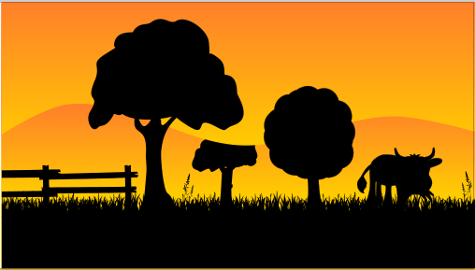

Now you will see that tree is behind the sky we select it by selector tool

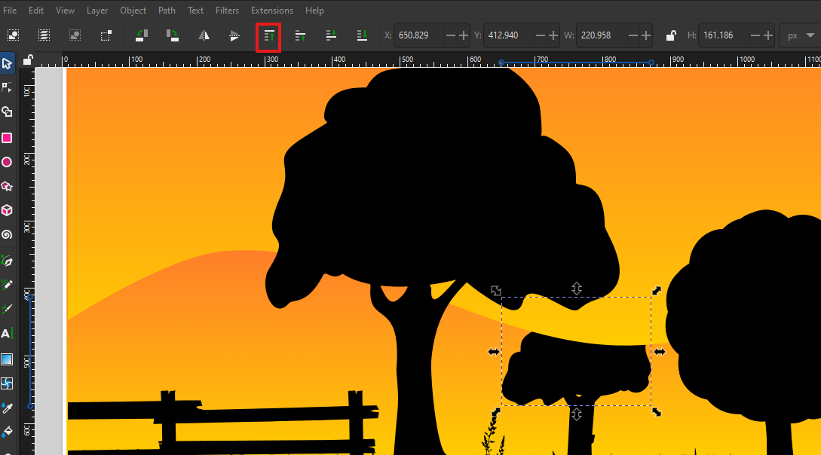

And then click on the marked option (maybe shown for a tool )

Now it come forward as shown below

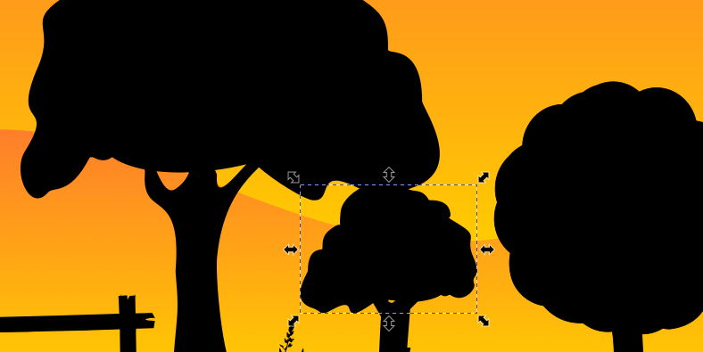

Center the Image back to the page border

If we right click on the object of the cow we will call it object but really there is a difference between paths and objects in vector this cow is a path so we right click on the path and then in sub menu click on the object properties as marked below

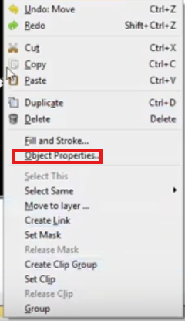

An now in Id as marked below

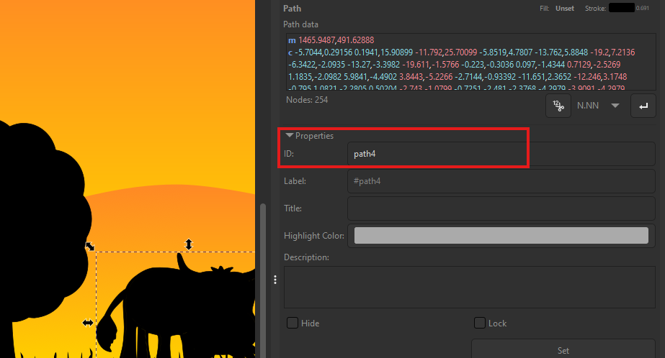

Type cow in place of path4 and then click on set button to set it

Similarly we set the name TreeTop for marked below

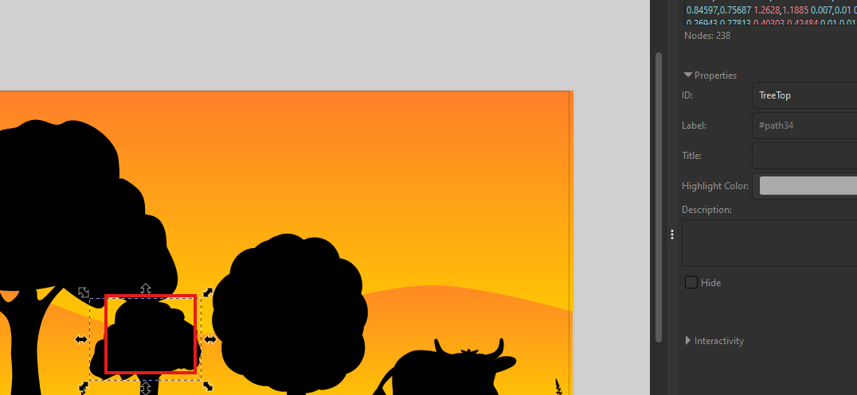

Now we name the orange background to sky.

Now we go to natron You did not see the updation in your read nodes so we delete them and then add them or restart your natron file

And it should have different option now

Always remember layer property will not be visible in read node properties but in merge properties but if you read a photoshop file(or image made by pixel) with layers then you can choosee which layer you want to read there but with vector file In the next lesson maybe we will play with the layers in Photoshop like this but in order to view individual elements we need to either use like we can use the **shuffle node** (who knows) we can use the merge node and a couple of different nodes have option actually a lot in those do for what part or elements of the file you are going to use so right now under A in Now you will seethe list of elements in the svg video It wil also show the elements we have renamed and also group we formed there we will see our cow.RGBA. Now it will show just our cow in our viewer panel as shown below

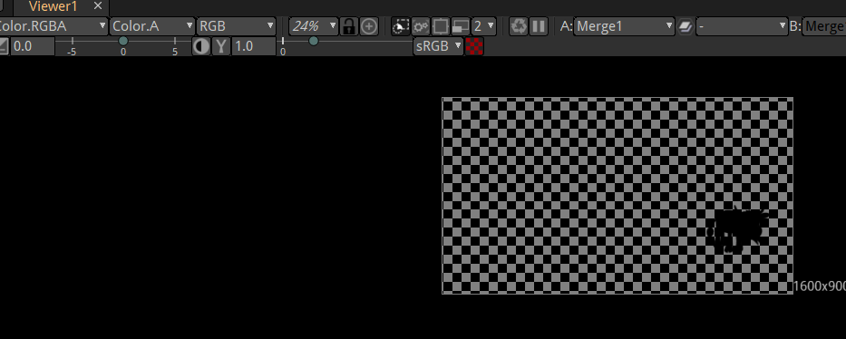

Now duplicate our read node and then set it for background and attach it to the B of the merge node. Now our node graph will look like below

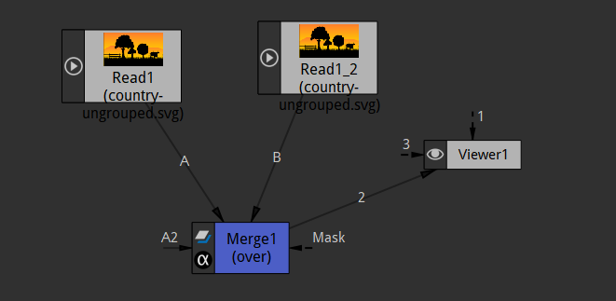

13:40

In A layer in merge node properties make it to cow.RGBA and in B layer make it sky.RGBA

But Teacher could not find the sky.RGBA in the merge properties because the sky in the case of Teacher svg image version the sky is an object we need to convert it into path we can do it Inkspace

So we select the object we want to convert that is an object and then we go to path menu and then in submenu go to Object to Path

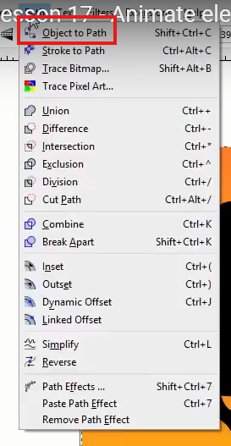

That might have been the problem according to the teacher (it was just a hit and trial from Teacher side).

So now Teacher read it again and find the sky.rgba in the B layer of the merge properties

Now the viewport look like below

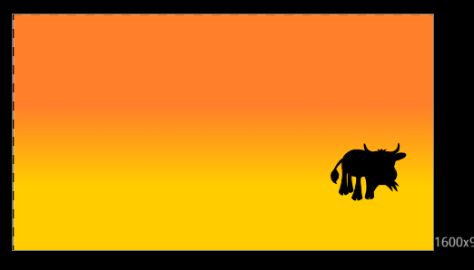

Now we can bring in third node that is copy paste the read node of svg image and then add it to the A2 of the merge node( dynamically created links that represent next object that to be added on top of previous A**n** layer for example if by merge node we want to add another layer on top of A layer then we add the read node to A2 and if on top of A2 then we add it onto A3 )

In A2 layer in merge node properties we choose g1.RGBA it is the thing that we grouped in Inkspace.

That does not contain sky, cow and treetop so we disable all other read node to see it and leave the read node in which we chose g1.RGBA and now our viewport look like below

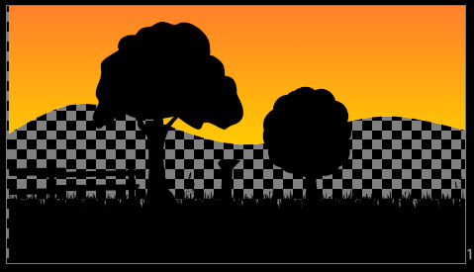

And now we disable all and this time enable the read node whiihc has sky now our viewport look like below

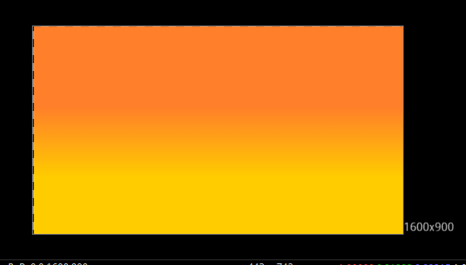

And now we enable all and now we have got a scene in the viewport here which is starting to look pretty cool as shown below

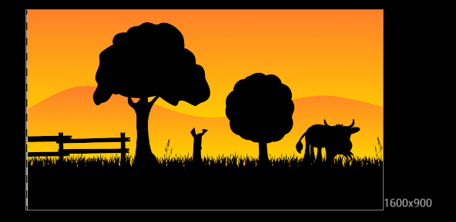

Teacher mean it looks the way it’s always looked right but we have different options for example we can take the cow and now we can rename the read nodes so that we can know what read node constitute what part of the svg image. By the way we can rename any node just go to properties of the particular node in the properties panel and then in the top left corner there is a field telling the name of the node as marked below

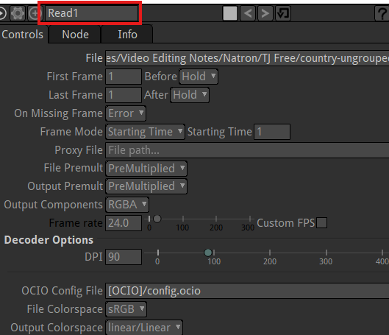

Now we now the rename the node that is representing cow that is our Read1_2 to cow and then press enter

Now you can see our one read node that is representing cow is named to cow as marked below in the node graph

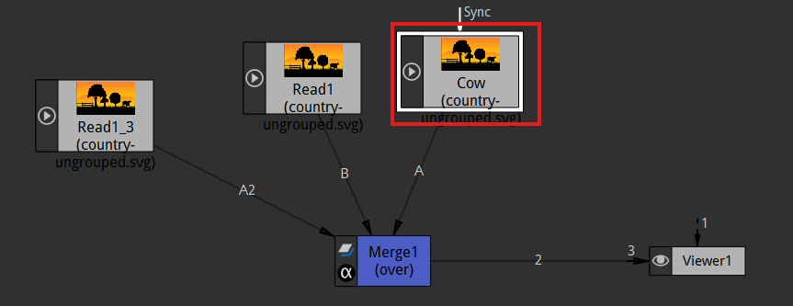

And now we rename the read node representing the grouped parts(that we made) of the svg image as Scene and similarly we rename the read node representing the sky as sky. Now our node graph will look like below

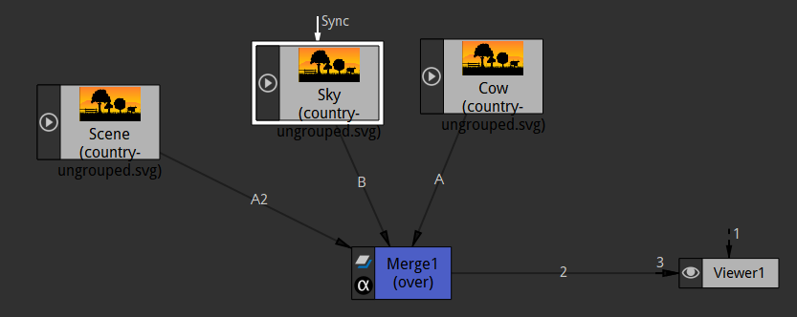

So now we know what these represent easily. So it makes it easier for us to see what’s happening

SO we also add our treetop so we again duplicate the read node and then in the merge layer this time A3 layer as it was added after A2 and in merge node for A3 layer we choose TreeTop and we named this read node as TreeTop

Now our node graph will look like below

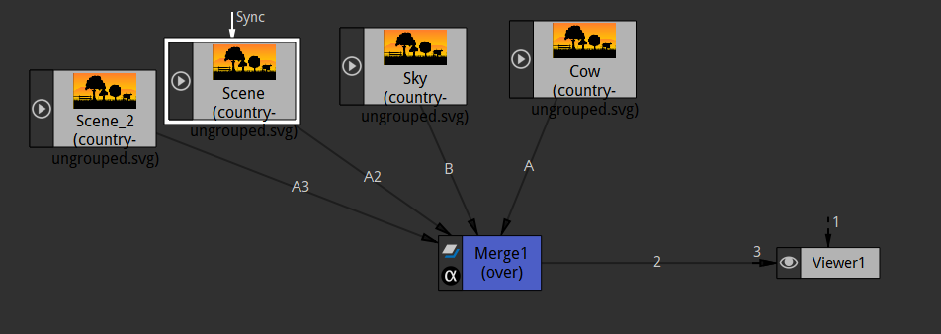

Now our node graph will look like below

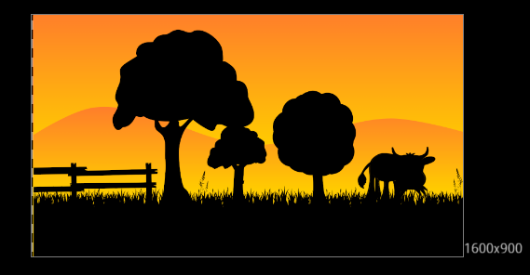

17:04

These naming convention are obviously optional. Just help you see what going on This is going to be a long lesson just do some animation on this we an add a transform node to the cow read node

Now our node graph will look like below

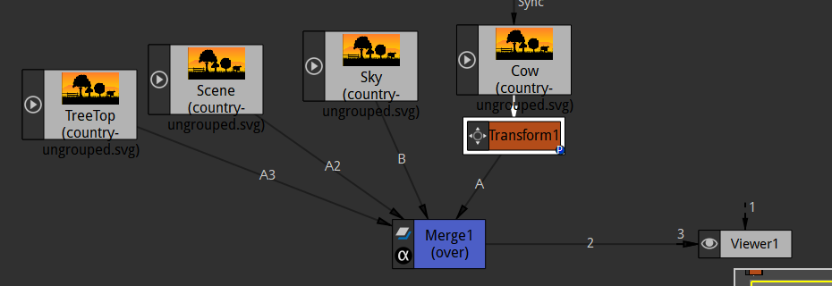

Now when you move the cow through transform gizmo as shown in the viewer node then the cow object and the gizmo are far apart due to which it get difficult to transform it as shown below

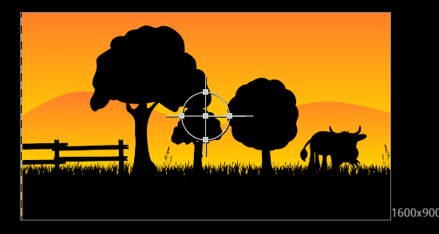

So to make the transform easy we need to enter it on the cow So to do it go to transform property and then go to centerx and centery field as marked below

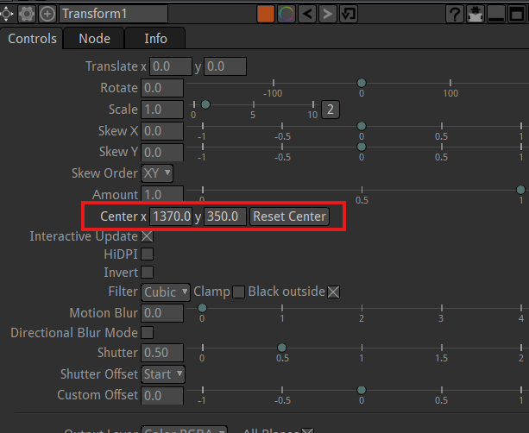

Now you can manipulate it so that the transform gizmo is move towards the cow

Now after I manipulated it then the gizmo will be like below over the cow



**Discovery:-**

When click on a numerical field and we scroll over it then it get incremented and decremented(according to the digit after which our cursor is ) by scroll up and scroll down.

We would like to do like above if we are gonna rotate the cow at all its good to have to have it in the center (because this gizmos act as a pivot point in terms of rotation)

Teach erobserved that cow is actually in lower layer so that if we move the cow then it will get hidden by th sky which comes at the top of it as shown below



Teacher was trying in Inskspace but the actual problem was in the natron merge node that we used

We make the scene A3 and the Cow due to which it was coming on top of it So we correct it now and make cow A3 and the scene A our node graph will look like below

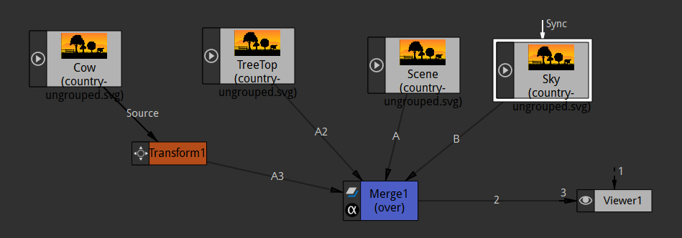

But Teacher think it is fine for this so he did not do the changes we did here. so Teacher add some keyframes here on the transform of cow. we add keyframe to 1 and then We come to 10 frames then do some transformation like moving up and then in 20 frames move down and then in frame 30 move up and frame 40 go down and in frame 45 slightly up. (We are making it behave like it is eating something) and then 50 up and then by frame 70 we will move it away from the scene



So we got this animation of the cow gonna kind of go along and it eat a little grass and then go out and we can come back to over to our tree top and add transform node to the Read node of TreeTop

Now we can make our treetop just kind of do something- like we can rotate it slightly so we set the keyframe on rotate

19:48

Now on frame 1 we add a rotate keyframe for tree tops and now we move to frame 16 and then we rotate the tree slightly and then at frame 35 rotate in reverse direction and then at frame 58 rotate in forward and make it look like wind is blowing s we go to frame 97 we rotate in reverse So now our animation of tree top is happening as shown below



So with the cow at the same time tree is gonna do its thing

Now we animate the sky object such that it move up during the video so that the sky changes its color as the sky object is a gradient from orange to yellow Now the video starts as dark and then its gonna become lighter because that background that is sky object gradient raising up

So we add translate keyframe on the sky at frame 1 and this time keep it down and then in frame 89 move it up

So now our animation will look like below



So yes there you have it and we use this all under one merge you could use multiple merges to do this. More or less Teacher wants to show us that some option for working with SVG graphics. We will render this out So by write node we will render this out

Now we connect the writer node to the last connected node to viewer node in this case our merge node and don’t forget to limit the frame range in Project panel so that only that frames are rendered out in which animation was applied so we did as marked bellow

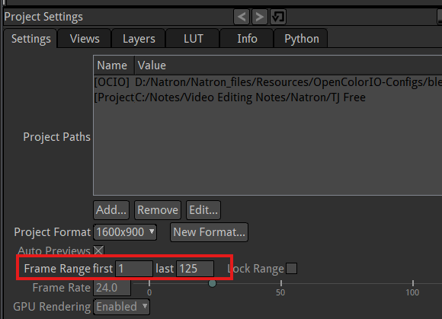

Now our node graph will look like below

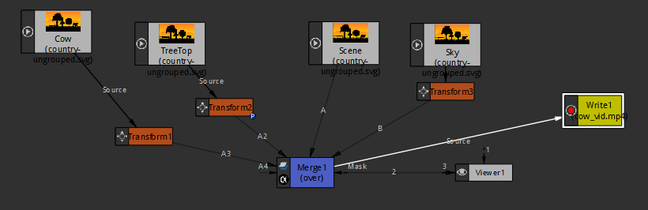

Now we click on render button in writer panel

**Note:-**

Now I have observed that if the render is not completely successful then we can still see the half render in the location where you half rendered video file is created

22:12

Now our exported video look like below



So we got this three shaking and cow eating some grass the background sky colors changing a little bit and we see that comes up because of the way Teacher did it. Well that is working with vector SVG like Teacher said you can do a lot with it and in future lesson maybe we will do like a UI interface (who knows) like you can do website or simulate like an Iphone app(who knows) or something in here so you can do a lot of cool things besides just cartoon animation but it is great for scene animation as well. See you in the next lesson.